[Session Index] − Technical Session [Session Number]: [Session Title]
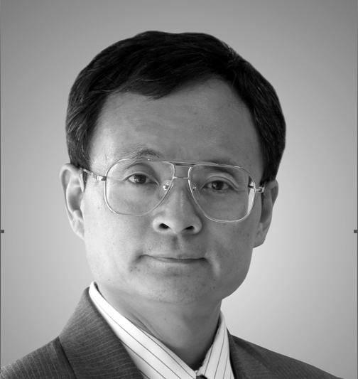

Title of the Talk

Qi Bi
Alcatel-Lucent Technologies
67 Whippany Road, Room 3D 210, Whippany, NJ 07981
qbi@alcatel-lucent.com

ABSTRACT

With the deployment of 3G wireless systems worldwide, two standards emerged to dominate the wireless industry for years to come. They are CDMA/1xEV-DO from 3GPP2 and UMTS/HSDPA from 3GPP. In this paper, we provide a detailed analysis of the core technologies used in the two standards that represent the state of the art for today’s communication systems. We start with the performance of channel coding performance and compare it with the theoretical Shannon limit. The coding gain gap between the Shannon limit and that achievable by the current standards is identified and various adaptive techniques such as adaptive coding and modulation, HARQ and control schemes are analyzed. Based on the analysis, we provide the expected performance of the two systems and their evolution to the future. In addition, we identify some of the key technologies that may be potential for further improvement for beyond 3G systems.

BIOGRAPHY

Dr. Bi got his M.S. from Shanghai Jiao Tong University and Ph.D. from Pennsylvania State University. After teaching at Utah State University as an assistant professor for one year, he joined Bell Laboratories as a Member of Technical Staff in 1988. In 1995, he became a Distinguished Member of Technical Staff and two years later, he was promoted to Technical Manager.

Dr. Bi is a recognized expert in wireless communications. He received Awards of Excellence from the Advanced Technology Lab of AT&T in 1996 and 1997, and received Bell Labs President’s Gold Awards in 2000 and 2002. Under his leadership, his team was recognized for its outstanding contributions in innovations and was awarded the Bell Labs Innovation Team Award in 2003. In 2004, he received the Speaker of the Year Award from the IEEE New Jersey Coast Section.

Based on his pioneering contributions in wireless communications, he broke new ground in 2003 by becoming the first Chinese from mainland China since 1949 to receive the prestigious Bell Laboratories Fellow Award. In 2004, he was also recognized by the Chinese Institute of Engineers and was awarded the Asian American Engineer of the Year Award during Engineers Week in the United States.

Dr. Bi is also dedicated to international and social activities. From 1998 to 1999, he served as the technical chair for the Wireless Mobile ATM Conference. From 1999 to 2000, he organized the first and the second CDMA conferences at Lucent Technologies. From 2000 to 2002, he served as the technical chair for IEEE Globecom’s wireless program. In 2003, he served as the technical chair for the IEEE Wireless Communications and Network Conference. Currently, he serves as the chair and organizer for the Wireless and Optical Communications Conference.

Dr. Bi has published extensively in many technical journals and conferences and has served as editors in many technical publications. He was often invited as a keynote speaker in many international conferences and has filed more than 50 US patents. He was also the New York chapter president of the Alumni Association of the Chiao Tung University from 2002 to 2006. He has been listed in Who’s Who since 2003.

