<Your abstract/bio/photo form should not be more than 1 page.>

Title of Your Talk/Poster  Qi Bi  Alcatel-Lucent Technologies  67 Whippany Road, Room 3D 210, Whippany, NJ 07981  qbi@alcatel-lucent.com | 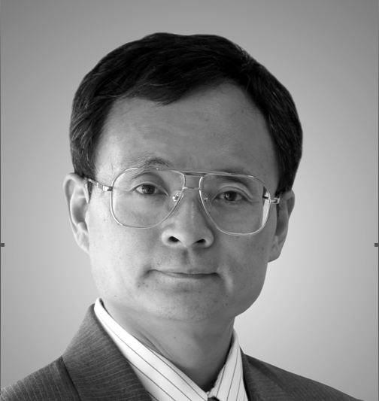
ABSTRACT: With the deployment of 3G wireless systems worldwide, two standards emerged to dominate the wireless industry for years to come. They are CDMA/1xEV-DO from 3GPP2 and UMTS/HSDPA from 3GPP. In this paper, we provide a detailed analysis of the core technologies used in the two standards that represent the state of the art for today’s communication systems. We start with the performance of channel coding performance and compare it with the theoretical Shannon limit. The coding gain gap between the Shannon limit and that achievable by the current standards is identified and various adaptive techniques such as adaptive coding and modulation, HARQ and control schemes are analyzed. Based on the analysis, we provide the expected performance of the two systems and their evolution to the future. In addition, we identify some of the key technologies that may be potential for further improvement for beyond 3G systems.

BIAOGRAPHY: Dr. Bi got his M.S. from Shanghai Jiao Tong University and Ph.D. from Pennsylvania State University. After teaching at Utah State University as an assistant professor for one year, he joined Bell Laboratories as a Member of Technical Staff in 1988. In 1995, he became a Distinguished Member of Technical Staff and two years later, he was promoted to Technical Manager.

Dr. Bi is a recognized expert in wireless communications. He received Awards of Excellence from the Advanced Technology Lab of AT&T in 1996 and 1997, and received Bell Labs President’s Gold Awards in 2000 and 2002. Under his leadership, his team was recognized for its outstanding contributions in innovations and was awarded the Bell Labs Innovation Team Award in 2003. In 2004, he received the Speaker of the Year Award from the IEEE New Jersey Coast Section.

Dr. Bi has published extensively in many technical journals and conferences and has served as editors in many technical publications. He was often invited as a keynote speaker in many international conferences and has filed more than 50 US patents. He was also the New York chapter president of the Alumni Association of the Chiao Tung University from 2002 to 2006. He has been listed in Who’s Who since 2003.

