The 10th Annual Wireless & Optical Communications Conference

Registration Form

April 20-21 (Friday-Saturday), 2001

The Newark Airport Marriott Hotel, Newark, NJ
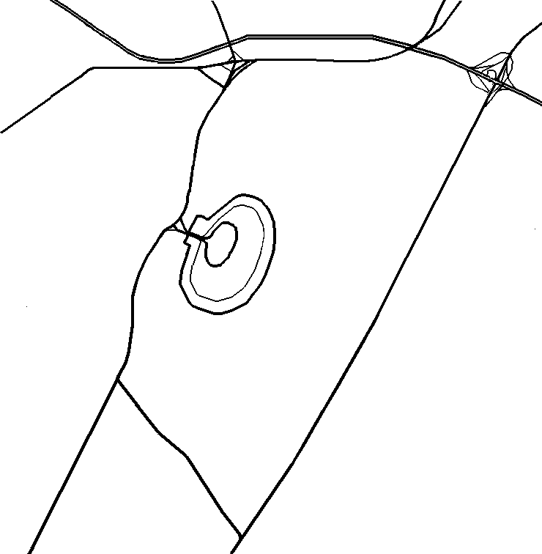
New Jersey Turnpike
Exit 13A
Exit 57
Marriott
Hotel
W
N
E
S
Last Name First Name Middle Chinese

Address (No., Street, City, State, Zip Code, Country)

Affiliation Tel (Home) Tel (Work)

Email

Registration Fee | Regular | Student
Before April 13, 2001 | $120 | $40
After April 13, 2001 | $150 | $40
Total Amount Enclosed | $

Additional Information
Payment:  - Only cash or check is accepted. Please make check payable to "CIE-USA" and mail to:  Wireless & Optical Communications Conference  126 East 56th Street 8 FL  New York, NY 10022  TEL: 212-752-2340  FAX: 212-826-3615  - Registration fee can be paid by mail or on site with the same discount rate as long as registration form is received by April 13, 2001. Lunch is included in the registration, but not guaranteed if the check is received after April 13, 2001. You may receive lunch allowance in lieu of lunch ticket.  - Meals for vegetarians are available by notifying the hotel official before the conference lunches. | Hotel Reservation and Parking:  - For pre-registration by e-mail (deadline April 13, 2001), please send the registration form to: hjsu@lucent.com. (Note the hotel reservation discount deadline is 8 days earlier on April 5, 2001.)  - Discount room rate for either single or double beds room of $99 per night +12% tax is available for WOCC conference.  - Please call 1-800-228-9290 or 973-623-0006 for reservation at the Newark Airport Marriott Hotel with group code "CIE". Discount reservation cut-off date is April 5, 2001.  - The hotel parking fee is $2 per day. Please mention the CIE conference at the exit.  - For more information, please visit our website: http://wocc.org
Driving Direction:

- Get on Route 1/Route 9, follow the sign to enter the Newark International Airport.
- Stay on left lane to enter the terminal area. DO NOT get off to the south and north area.
- Stay on the middle lane which splits off the first time from left to the car rental area.
- Once pass the split, stay on the left lane. Before entering terminal A, the last lane sign shows Long-term parking/Monorail/Marriott Hotel. Get off and proceed to arrive at Marriott.

Note: The Newark Airport Marriott Hotel is in the middle of Newark International Airport parking lot and is surrounded by three terminals A, B, and C

